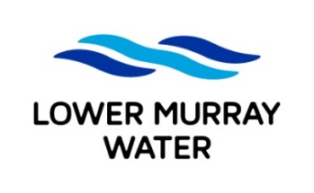
Job Application Form

To apply for an LMW position, complete the following fields, attach your current resume and email to recruitment@lmw.vic.gov.au before the specified closing date/time

POSITION DETAILS
Advertised job title: | Project Officer/Engineer (Electrical)
YOUR DETAILS
Full name:
Email:
Mobile:

LMW is a future-focused organisation which embraces the use of technology such as generative AI (Artificial Intelligence) in supporting and enhancing the work we do.

To ensure the integrity of our recruitment process and an accurate assessment of your application, we encourage you to submit the form in your own words to reflect your lived experience and values.

APPLICATION QUESTIONS
In addressing the application questions below please include details on your relevant:
- skills/knowledge
- qualifications/licences/certificates
- examples of experience
- Which of the following statements best describes your right to work in Australia?
☐ I have permanent work rights with no restrictions.

☐ I have temporary work rights with no restrictions.

☐ I have temporary work rights with restrictions.

☐ I require sponsorship to work for a new employer.

- What skills will you bring to the role? – 500 words max.
- What has been your most challenging project to date? What was the issue? How did you resolve it? – 500 words max.
- Where do you see yourself in 5 years' time, and how do you see LMW supporting that? – 500 words max.

