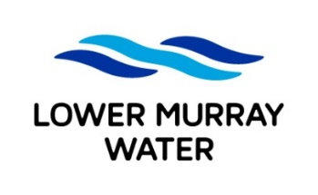

**Job Application Form**

**Leading Hand – Civil Maintenance**

|  |  |  |
| --- | --- | --- |
| **POSITION DETAILS** | | |
| Advertised job title: | **Leading Hand - Civil Maintenance** | |
|  | |  |
| **YOUR DETAILS** | | |
| Full name: |  | |
| Email: |  | |
| Mobile: |  | |

|  |
| --- |
| **APPLICATION QUESTIONS** |

|  |
| --- |
| In addressing the application questions below please include details on your relevant:   * skills/knowledge * qualifications/licences/certificates * examples of experience |
| 1. Which of the following statements best describes your right to work in Australia? |
| ☐ I have permanent work rights with no restrictions.  ☐ I have temporary work rights with no restrictions.  ☐ I have temporary work rights with restrictions.  ☐ I require sponsorship to work for a new employer. |
| 1. Why do you want to be a Leading Hand – Civil Maintenance at LMW and what skills or experience will you bring to the role? – 500 words max. |
|  |

|  |
| --- |
| 1. How do you promote a safety-first work culture, when performing high risk work? – 500 words max. |
|  |
| 1. What does good leadership look like to you and how have you shown this in previous roles, even if you did not have staff directly reporting to you. – 500 words max. |
|  |