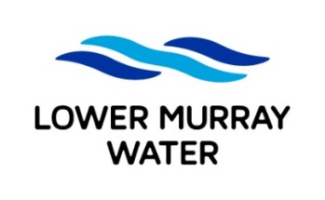
Job Application Form

To apply for an LMW position, complete the following fields, attach your current resume and email to recruitment@lmw.vic.gov.au before the specified closing date/time

POSITION DETAILS
Advertised job title: | Mechanical Maintenance Operator
YOUR DETAILS
Full name:
Email:
Mobile:

APPLICATION QUESTIONS
In addressing the application questions below please include details on your relevant:
- skills/knowledge
- qualifications/licences/certificates
- examples of experience
1. Which of the following statements best describes your right to work in Australia?
☐ I have permanent work rights with no restrictions.

☐ I have temporary work rights with no restrictions.

☐ I have temporary work rights with restrictions.

☐ I require sponsorship to work for a new employer.

- Why do you want to be a Mechanical Maintenance Operator at LMW and what skills or experience will you bring to the role? – 500 words max.

3. How do you promote a safety-first work culture, when performing high risk work?? – 500 words max.

