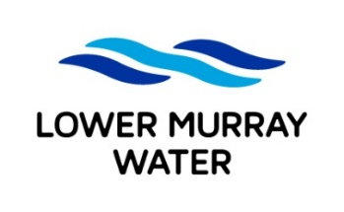
Job Application Form

To apply for an LMW position, complete the following fields, attach your current resume and email to recruitment@lmw.vic.gov.au before the specified closing date/time

POSITION DETAILS
Advertised job title: | Team Leader People
YOUR DETAILS
Full name:
Email:
Mobile:

APPLICATION QUESTIONS
In addressing the application questions below please include details on your relevant:
- skills/knowledge
- qualifications/licences/certificates
- examples of experience
1. What is the value that you believe HR brings to an organisation? – 500 words max.
2. What skills and experience will you bring to the role to achieve this value? – 500 words max.

