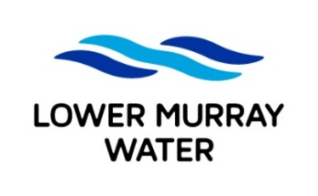
Job Application Form

To apply for an LMW position, complete the following fields, attach your current resume and email to recruitment@lmw.vic.gov.au before the specified closing date/time

POSITION DETAILS
Advertised job title: | Customer Service Officer
YOUR DETAILS
Full name:
Email:
Mobile:

APPLICATION QUESTIONS
In addressing the application questions below please include details on your relevant:
- skills/knowledge
- qualifications/licences/certificates
- examples of experience
1. Why do you want to be a Customer Service Officer at Lower Murray Water? – 500 words max.
2. What experience do you have working in complex customer service roles? – 500 words max.

