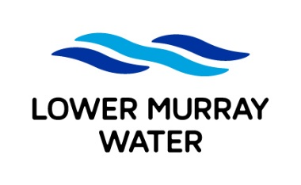
Pressure and Flow
Application Form

Lower Murray Water
03 5051 3460 http://www.lmw.vic.gov.au

Information To Be Provided
- Pressure available for 95% of the time;
- The available pressure at the following flow of 5, 10, 15 & 20 LPs

Applicant Details
 | Name
 | Title |  | Surname |  |  |  |  |  |  | Given Name 1 |  |  |  |  |  | Given Name 2
 | Address
 | Postal Address
 | Suburb / Town |  |  |  |  |  |  |  |  |  | State |  |  |  | Postcode
 | Contact Details
 | Business phone |  |  |  | Mobile
 | ( )
 | Email

Test Location
 | Property Details
 | Street Number |  |  | Street Name
 | Lot Number |  |  | Plan Number
 | Suburb / Town

Mandatory Supporting Documents
- Site plan depicting desired connection location

Payment Details
The Processing fee of $320.80 can be paid in person at Lower Murray Water or email property.services@lmw.vic.gov.au to obtain a Credit Card Authority Form to process your payment electronically. Please note that above fee is current for 2023/2024 financial year and is only current to 30th June 2024.
Please note your application will not be processed until we have received your payment.

Privacy Statement
Lower Murray Water supports and endorses the provisions of the Information Privacy Act 2000 and has implemented a policy for the collection and handling of personal information.

Lodgement
 | To lodge this application or if you require information on this application please use the details below:
 | Postal Address: | Lower Murray Water |  | Email: property.services@lmw.vic.gov.au
 |  | PO Box 1438 |  | Telephone: (03) 5051 3460
 |  | Mildura VIC 3502 |  | Website: http://www.lmw.vic.gov.au
 | Office Location: | 741-759 Fourteenth Street, Mildura

Acknowledgement
I understand and acknowledge that:
- The information provided in this application is true and complete to the best of my knowledge.
- This test will provide mains pressure at the desired point of connection
By ticking this checkbox I confirm that I have read and understood all the statements above.

(Print Name of Applicant)

Privacy
LMW is committed to protecting personal information provided by you in accordance with the principles of the Victorian privacy laws. The information you provide will be used to provide water and sewer services and will generally be made available to employees/contractors to allow services to be provided to you. If all the requested information is not provided, LMW will be unable to process your request/application. You may access the information you have provided to LMW by emailing us at privacy@lmw.vic.gov.au

